K. J. Somaiya College of Engineering, Mumbai-77
(Autonomous College Affiliated to University of Mumbai)
Semester: January 2017- April 2017
Max. Marks: 30 Duration: 1hr.15 min.

Class: B E Semester: VIII

Branch: COMP Course Code: UCEE801

Test 1 Name of the Course: Machine Learning

Question No. |  | Max.  Marks | *CO  Mapped | Bloom’s Taxonomy
1 | The sales of a company (in million dollars) for each year are as given below  - Find the least square regression line y = ax + b  - Use the least squares regression line as a model to estimate the sales of the company in 2012. | 06  04 | 02 | Application  analysis
  x (year) | 2005 | 2006 | 2007 | 2008 | 2009
  y (sales) | 12 | 19 | 29 | 37 | 45
2 | What is machine learning ?  Explain in details various types of machine learning techniques and give example of each type of machine learning. | 10 | 01 | knowledge
3 | 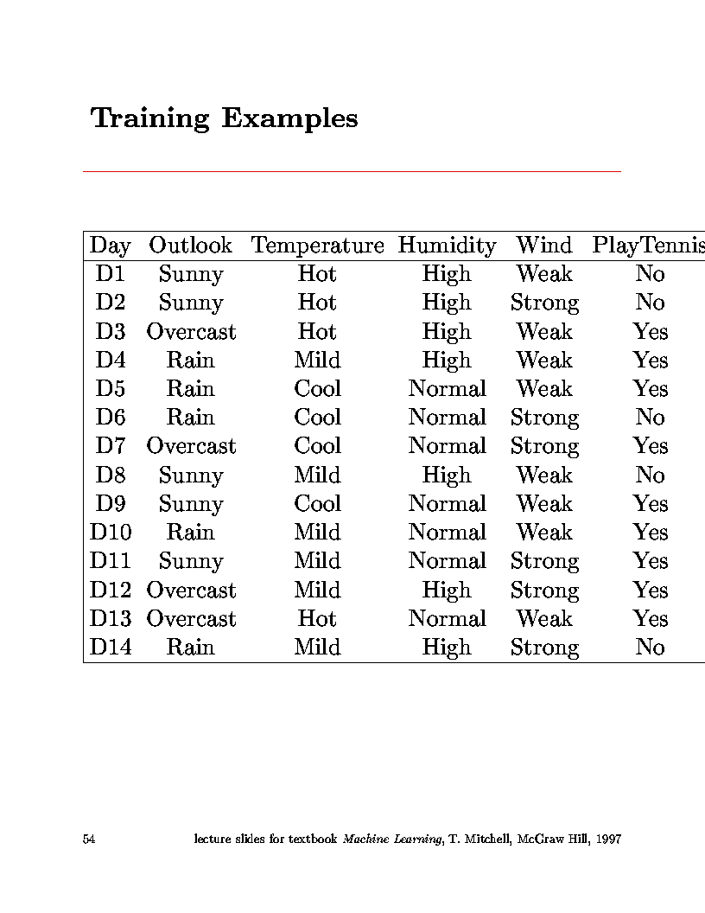  For the given example data, Show the calculations and steps of decision tree root node ‘Outlook’ by information gain method. | 10 | 02 | synthesis

